Q1. Explain Transaction Processing with its properties?

Q2. Explain States of Transaction Processing with proper diagram?

Q3. What is a Schedule . Explain different type of schedule?

Q4. What is Serializability. Explain different type of schedule.

Q5. Explain Oracle case study in detail(Basic Structure, Storage Organization)

Q6. MCQs

1. Transaction ………. ensures that the transaction are being executed successfully.  
   A. concurrency  
   B. consistency  
   C. serialisability  
   D. non serialiasability
2. Consider the following transaction involving two bank accounts x and y.

read(x); x := x – 50; write(x); read(y); y := y + 50; write(y)

The constraint that the sum of the accounts x and y should remain constant is that of

**(A)** Atomicity  
**(B)** Consistency  
**(C)** Isolation  
**(D)** Durability

1. **Consider the following transactions with data items P and Q initialized to zero:**

T1: read (P) ;

read (Q) ;

if P = 0 then Q : = Q + 1 ;

write (Q) ;

T2: read (Q) ;

read (P) ;

if Q = 0 then P : = P + 1 ;

write (P) ;

**Any non-serial interleaving of T1 and T2 for concurrent execution leads to**  
(A) A serializable schedule  
(B) A schedule that is not conflict serializable  
(C) A conflict serializable schedule  
(D) A schedule for which a precedence graph cannot be drawn

1. Consider the following four schedules due to three transactions (indicated by the subscript) using read and write on a data item x, denoted by r(x) and w(x) respectively. Which one of them is conflict serializable.

[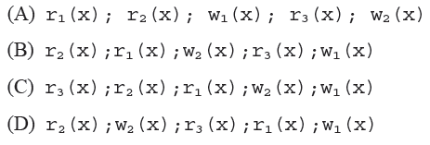](http://www.geeksforgeeks.org/wp-content/uploads/gq/2014/04/GATECS2014Q39.png)

Q6. Explain Concurrency Control? Also Explain Concurrency control Protocols